**Leader Overview**

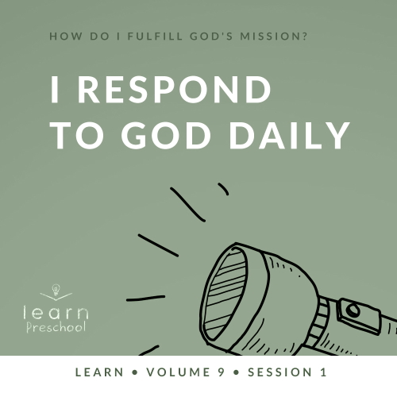

**Volume Overview**

**How do I fulfill God’s mission?**

*Christianity is so much more than only another religion. It’s not just another collection of rules and regulations. It’s a real relationship with Jesus Christ. When we give our heart to Jesus, He becomes our Savior and our Lord. Life is not only full of responsibilities, bills, and work, but it can also be full of eternal purpose.*

*As we grow closer to God, He begins to reveal His true purpose and plans for our life. We begin to discover the personal mission and assignment He has designed for each of us. While we may have different gifts, talents, and abilities, each of us is called to the same mission of helping to transform the world with God’s love and power. God calls us to personally share our faith, to help lead others toward a deeper walk with Christ, and to help others fulfill their individual mission. As we lean into God and allow Him to make a difference in our life, He will in turn use us to make a difference in the life of others.*

**Session Overview**

**I Respond to God Daily**

*In this* **Learn** *session, preschoolers will discover that God loves to use us to accomplish His plans. He has a plan and purpose for each of one of us. It is our job to trust His plans and to respond obediently to the things God tells us to do. Through the life of Ananias, we will see how God always takes care of people when they trust and follow Him.*

**Bible Lesson**

Ananias Responds to God

[Acts 9:10–18](https://ref.ly/logosref/Bible.Ac9.10-18)

**Faith Fact**

God has plans for my life.

**Faith Verse**

[Matthew 28:19](https://ref.ly/logosref/Bible.Mt28.19) (NLT)

“Therefore, go and make disciples of all the nations, baptizing them in the name of the Father and the Son and the Holy Spirit.”

**Preparing for the Session**

**Leader Preparation Time: 20–25 Minutes**

|  |
| --- |
| ***You Will Need***  ***Preservice Activities***  *• Toys*  *• Packaged snacks (Fruit snacks, chips, etc.)*  ***Large Group***  *• Bible*  *• Worship songs (Song suggestions: “Love Will Never End” by KidSpring Children’s Ministry; “Higher Than the Sky” by Gateway Kids Worship; “Move” by Gateway Kids Worship)*  *• For groups not using a phone or tablet only, add:*  *• Projector or TV*  *• Laptop*  *•* ***Faith Fact Sound*** *video (bell ringing)*  *•* ***Faith Fact Slide***  *•* ***Faith Verse Slide***  *•* ***Bible Lesson Video A***  *•* ***Bible Lesson Video B***  ***Small Group***  *•* ***Small Group Activity Page****, one per kid*  *•* ***Small Group Activity Page Answer Page****, one per leader*  *• Crayons or markers*  *• Small plastic cups, ten per group*  *• Painter’s tape*  *• Basketball or volleyball*  *• Table tennis ball*  *To access session content and videos from a computer, visit:* [***BibleEngagementProject.com/downloads***](https://bibleengagementproject.com/downloads) |
| ***Getting Ready***  ***Preservice Activities***  *• Set out toys and snacks.*  ***Large Group***  *• Download videos and slides if needed.*  *• Select worship song(s) and have them ready to play.*  *Small Group*  *• Print copies of the* ***Small Group Activity Page****, one per kid and one* ***Small Group Activity Page Answer Page*** *for the leader.*  *• Place two lines of painter’s tape along the floor about 5 feet apart for kids to sit on.*  *• Place a small piece of tape centered in the space between the two taped lines.*  ***First time leading* Learn *for Preschool? Check out the*** [**Facilitator Guide**](https://0b769b0ed3569ef9d18b-f88d8272f61086866d50d048b43ef630.ssl.cf2.rackcdn.com/sites/biblengagementproject/Listen_Facilitator_Guide.pdf)**.** |

**Preservice Activities**

*See what’s needed at the beginning of the session.*

**Bible Story Warm-Up**

Today, we’ll learn about responding. Does anyone know what the word *responding* means? *(Allow responses.) Responding* is a big word to say that you’ll do something because someone said or did something first. If I said, “Thank you,” most people would respond by saying what? *(Group response)* That’s right, they would respond and say, “You’re welcome!” I said something, and you responded.

What about when someone sneezes? *(Make sneezing sound.)* What do people say*? (Group response)* God bless you! It’s that simple. Let’s practice responding now. When I ask you these questions, respond with your answer.

How old are you?

How are you today?

What’s your name?

Would you respond to me if I called you by the wrong name? *(Group response)* I didn’t think so. There are lots of people and things in life trying to get our attention, so it’s important that we know who to listen to. Who do you always listen to every day? *(Allow responses.)*

Those are important people to respond to. In our Bible story, we’ll find out what we should do when God speaks to us. This might seem like a big thought right now, but we’ll learn about this together.

**Snack**

**Packaged Snack (Fruit snacks, chips, etc.)**

Isn’t it cool that God would choose to speak to us about helping Him do big things and wait for us to respond to Him? God doesn’t need us to help Him, but He loves when we do. Today, I’ve asked *(kid’s name)* to help hand out our snack. When I asked, my helper had a choice of how to respond. I’m so excited that *(kid’s name.)* responded, “Yes!” As my helper hands out your snack, be sure to respond to their kindness by saying, “Thank you.”

• *Have one kid hand out the snacks.*

**Free Play**

*Any extra time can be spent playing with toys.*

**Transition**

*A few minutes before service begins have kids make their way to the large group area and sit in their designated areas.*

**Large Group**

**25 Minutes**

*See what’s needed at the beginning of the session.*

**Introduction**

Hey, friends! I’m excited because today I have the best job. I get to hang out with you! We’ll have so much fun learning from God’s Word together. *(Hold up Bible.)* If you’re excited to learn with me, stomp your feet three times on the count of three. Ready? 1, 2, 3! *(Group response)*

Today, we’ll learn about a time in the Bible when God told someone to do something he wasn’t so sure he wanted to do. Even though this man was a little scared to do what God said, he obeyed God and responded to Him in the right way. He trusted that God had a plan and purpose for his life.

**Faith Fact**

As amazing as that sounds, I have something even more amazing to tell you. God didn’t have a purpose just for that man’s life. He has one for your life. In fact, that sounds like our Faith Fact. **God has plans for my life.**

• *Show the* ***Faith Fact Slide.***



Let’s say our Faith Fact together. **God has plans for my life.** Let’s pretend we’re going on a long journey. Put on your backpack. Now, let’s march in place as we say the Faith Fact. **God has plans for my life.** Awesome! On our journey, let’s pretend we see a bear. How would we respond? *(Allow responses.)* I’d run as fast as I could. Let’s run in place and say the Faith Fact as loudly as we can. Ready? **God has plans for my life.** Whew! Great job responding quickly!

**Bible Time**

Isn’t it great that God has plans for you and me? *(Group response)* He loves us so much that He gives us a plan for what we should do and how we should live. One way to discover God’s plans for our life is to read the Bible. He gave us the Bible as a guide. As we read God’s Word, we can show God we love Him by responding and doing what it says. Why don’t we see what Lizzy and Grandpa are up to right now? I think they have something to teach us from the Bible.

• *Play* ***Bible Lesson Video A***.

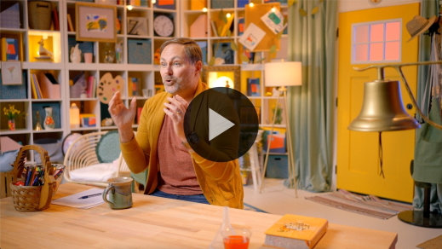

Fantastic! I love that Bible verse. It teaches us about a very important job that God has for us. He wants every one of us to tell other people how much He loves them. That’s why we’re learning this Bible verse. As you read God’s Word and talk to Him, you’ll discover God’s plan for your life. He has a special plan just for you. We’ll find out more about that in our Bible story, but first, let’s worship Him.

**Worship**

We can respond to God and trust His plans for our life. When we trust Him, we’re telling Him that we know He will take care of us and love us. When we worship, it’s a special time to tell God how much we love Him. Let’s respond to God’s love in our life by taking time to focus on Him as we worship.

**Praise**

Are you glad God is here with us? Touch your toes down low. *(Group response)*

Are you thankful that God has a plan for your life? Say, “Oh, yeah!” *(Group response)*

Who wants to tell God, “Thank You”? Wave your hands up high. *(Group response)*

**Sing**

Worship isn’t only the words we say. It’s also the focus we have as we respond. When we sing these words, let’s focus on God.

• *Lead the kids in singing one or two songs. See song suggestions at the beginning of the session.*

**Prayer**

That was beautiful! I love to hear you worship God. I know He loves it even more. God loves to hear from you. He loves when you sing to Him and when you talk to Him. Let’s take a minute and talk to Him right now. Let’s pray.

|  |
| --- |
| Dear God, thank You for always being with us. We’re excited to learn more about Your plans for our life. Help us to always respond to what You tell us to do by saying yes. We trust Your plans. Amen. |

**Bible Time cont’d**

Wow! You have responded so well today. You’ve listened so well and worshipped so loudly. I love learning more from God with you. Hey, I have an idea! Let’s check back in with Lizzy and see what we can learn together.

• *Play* ***Bible Lesson Video B.***

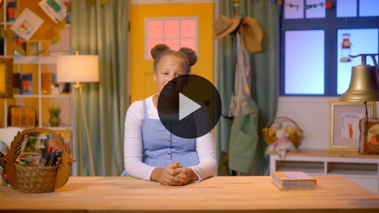

You did such a great job responding to Lizzy as she solved those clues today. God had a specific plan for Ananias. Who did God send him to talk to? *(Group response)* That’s right, He sent Ananias to Saul. People who loved Jesus were scared of Saul because he wanted to put them in jail. But God had a different plan. When Saul met Jesus, his life began to change.

Ananias played a big part in God’s plan for Saul, but he was scared to go and pray for Saul. Ananias had a tough decision to make, didn’t he? *(Group response)* He had to decide how he was going to respond to God. Ananias was scared to go and pray for Saul, but he trusted God’s plan and responded by obeying. He did exactly what God told him to do.

**Response Time**

Ananias was probably used to talking to God. The way he responded to God makes it seem like he must have spent a lot of time with God. The more time we spend with God, the easier it is to respond and obey what He tells us to do. Let’s take some time and respond to God right now.

Did you know that you can respond to God every day? You don’t have to be at church to respond to God. You can respond to Him at night when you go to bed, when you’re riding in the car, or even when you’re playing on the playground. Wherever you are, you can respond to God.

Let’s respond to God right now. Place your hands out like you’re ready to hold something. (*Place hands in receiving position.)* Let’s sit quietly and listen to God. Then we’ll pray and ask God to give us the courage we need to respond to Him and trust His plans for our life.

• *Optional: Have the kids repeat phrases of the prayer after you.*

|  |
| --- |
| Dear God, I want to respond to You. Show me what You want me to do. Help me to focus on You throughout my day. I don’t want to miss You speaking to me. Please give me courage like Ananias to trust and obey Your plans. I love You. Amen. |

**Faith Verse**

Did you know God loves it when we learn verses from the Bible, His Word? It shows Him how much the Bible means to us. Why don’t we all practice our Faith Verse again?

[Matthew 28:19](https://ref.ly/logosref/Bible.Mt28.19) (NLT)

“Therefore, go and make disciples of all the nations, baptizing them in the name of the Father and the Son and the Holy Spirit.”

• *Show the* ***Faith Verse Slide***.

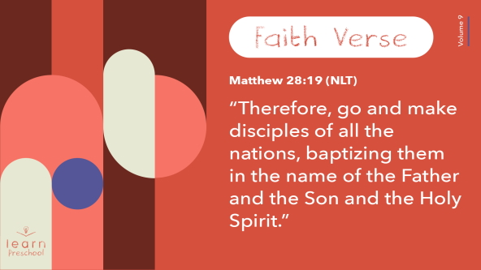

**Matthew** *(hands at waist, spread apart, palms up and out)*

**28:** *(hands together like a clap)*

**19** *(hands opened to “book”)*

**“Therefore, go and make disciples** *(walk in place, moving arms)*

**of all the nations,** *(hands at waist, palms facing down in front, move to sides)*

**baptizing them** *(both thumbs to the side, then straight up)*

**in the name of the Father** *(left hand raised overhead)*

**and the Son** *(keep left hand raised and raise right hand overhead)*

**and the Holy Spirit.”** *(turn in a circle with hands raised overhead)*

You’re doing fantastic learning our Faith Verse!

**Closing**

Who learned more about God today? *(Group response)* I did. It’s always so much fun to learn together. We’ve done so much. We’ve learned, worshipped, and prayed together.

• *Play the* ***Faith Fact Sound*** *video (bell ringing).*

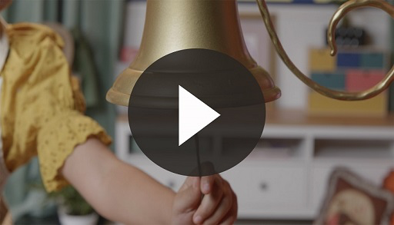

That sound means it’s time to review our Faith Fact. It’s so important. **God has plans for my life.**

• *Show the* ***Faith Fact Slide.***



Everyone, grab your imaginary backpack again. *(Put on pretend backpack.)* Following God’s plan for your life is like walking on a path. Let’s pretend we have walking sticks *(demonstrate)* and march in our spot as we say our Faith Fact. Ready? **God has plans for my life.** Now, let’s say it one more time as we tiptoe as quietly as we can. Ready? **God has plans for my life.**

**Dismissal to Small Groups**

Awesome job! Let’s keep the fun going as we head to our small group circles.

• *Dismiss the kids by groups*.

|  |
| --- |
| ***Leader Tip:*** *This can be done by assigning color teams or by age groups. Note that some young preschoolers may not know their age. Using a colored sticker, jersey, or wristband will help separate the kids and help identify their small groups.* |

**Small Group**

**25 Minutes**

*See supplies and prep instructions at beginning of session or in each activity below.*

|  |
| --- |
| ***Leader Tip:*** *Small groups can alternate to each circle, or all groups can do each activity at the same time. If you choose to alternate, you will need at least one leader per circle.* |

**Circle 1**

**Group Connection**

**Hand Clapping Game**

What has been your favorite part of our time together so far? *(Allow responses.)* I’m glad you are enjoying our time together. Our Faith Fact today reminds us that God has plans for our lives. Did you know that God’s plans are always the best plans? *(Group response)* When we trust God and follow Him, we’re winners. When we respond to Him and obey what He says, He will help us follow His plans.

• *Have kids sit in a circle close enough to hold hands.*

Let’s try something to help us to remember to be quick to respond yes to God’s plans. This game is called the Hand Clapping Game. Everyone, hold out your left hand and rest it on your left leg like the person next to you is going to give you something. Keep your left hand in place. Now take your right hand and hold it up like you want to ask a question.

• *Make sure kids have their left hand out and resting on their left knee and their right hand up in the air.*

Here’s the challenging part. We’re going to pass the hand clap around the circle. I’ll start by clapping my right hand on my neighbor’s left hand. Then, my neighbor will clap the left hand of the next person until we’ve gone around the circle and back to me. Let’s try it.

• *Start the hand clap slowly until the kids understand what to do.*

Are you ready to respond to an even harder challenge? *(Group response)* This time when the person next to you claps your hand, respond as quickly as you can to pass it to the next person. If I say, “Freeze,” everyone stops. The person who has the hand clap will say today’s Faith Fact. Let’s all say it together before we play. **God has plans for my life.**

• *Start the game again.*

• *At any point, say, “Freeze.” Whoever has the hand clap will say the Faith Fact.*

You were so fast! You did such a great job passing the hand clap around the circle. Remember, when we respond to God, we should quickly say yes to His plans for us.

**Circle 2**

**Activity Page Time**

**Follow God’s Plan Maze**

|  |
| --- |
| ***You Will Need***  *•* ***Small Group Activity Page****, one per kid*  *•* ***Small Group Activity Page Answer Page****, one per leader*  *• Crayons or markers*  ***Getting Ready***  *• Print copies of the* ***Small Group Activity Page****, one per kid and one copy of the* ***Small Group Activity Page Answer Page*** *for the leader.* |

God has plans for each one of us. Does anyone know what helps us discover God’s plan? *(Allow responses.)* The Bible helps us know God’s plans. Sometimes God speaks to us. That’s what happened in our Bible story about Ananias.

• *Have a kid help you hand out a copy of the* ***Small Group Activity Page*** *and crayons or markers to each kid.*

God spoke to Ananias and told him to go and find Saul. Your job is simple. Make your way through the maze to help Ananias go to Saul.

• *During the activity, interrupt and practice the Faith Fact:* **God has plans for my life**.

• *Play the* ***Faith Fact Sound*** *video. Review the Faith Fact even if you can’t play the sound.*



**Circle 3**

**Feet-to-Floor Game Time**

**Speedy Response Time**

|  |
| --- |
| ***You Will Need***  *• Small plastic cups, ten per group*  *• Painter’s tape*  ***Getting Ready***  *• Place two lines of painter’s tape along the floor about 5 feet apart for kids to sit on.*  *• Place a small piece of tape centered in the space between the two taped lines.* |

Who is ready to play a game? *(Group response)* Awesome! We’re going to divide the group into two teams.

• *Assign kids to teams and have them sit on their team’s line.*

Now, I’m going to give each of you a number. It’s very important that you remember this number. There will be someone on the other team with the exact same number as you.

• *Assign numbers to kids.*

I’m putting two cups in the center of the area. When I call your number, you will respond as fast as you can by picking up a cup from the middle and taking it back to your seat. Whoever gets the cup to their seat first will get a point for their team. It’s important to pay attention and listen closely for your number so that you can respond quickly when I call it.

• *Play the game so that every kid gets a turn.*

• *After each turn, place two cups in the middle of the playing area.*

Wow! You all did an incredible job of listening and responding as I called your numbers. Great job!

**Circle 4**

**Hands-On Learning**

**Planned Effect**

|  |
| --- |
| ***You Will Need***  *• Basketball or volleyball*  *• Table tennis ball*  *No prep needed for this activity.* |

When God wants us to obey, we have a choice like Ananias did. He could have ignored God and done what he wanted to do that day. *(Hold up table tennis ball.)* When I drop this ball, it doesn’t bounce very high by itself. *(Drop the table tennis ball.)* When we try to do things on our own, we might not get much done.

We’ve talked about responding to God. He has plans for us just like our Faith Fact says. **God has plans for my life.** It’s incredible that God has plans for each of us. When we trust God’s plan, He takes what we can do and makes it so much better.

While He has a specific plan for each one of us, He also has plans for all of us that are the same. He wants us to show others His love. When we trust God’s plan and begin to show others His love, He takes what we can do and makes it so much better.

• *Stand up and hold the table tennis ball on top of the basketball.*

• *Drop the balls together at the exact same time. The force from the basketball bouncing on the floor will cause the table tennis ball to fly into the air at a much higher speed.*

Wow! Did you see how the basketball made the table tennis ball fly through the air? *(Group response)* If we all respond together, God will help us make a big difference.

**Dismissal**

• *Play the* ***Faith Fact Sound*** *video (bell ringing).*



• *Show the* ***Faith Fact Slide.***



One last time before we go, let’s say the Faith Fact together. **God has plans for my life.** Fantastic! I had a great time learning more about responding to God with you. I can’t wait to see you next time!

• *Send home the* ***Small Group Activity Page*** *with each kid.*

• *Remind parents that there are* ***Family Devotions*** *available on the app to do with their kid.*

• *Tell everyone the date and time for the next session.*